**Week-3**

**Task-3**

**Lab 3: Using EF Core CLI to Create and Apply Migrations**

using var context = new RetailContext();

if (!context.Products.Any())

{

context.Products.Add(new Product { Name = "Keyboard", Quantity = 10, Price = 1499 });

context.Products.Add(new Product { Name = "Mouse", Quantity = 25, Price = 599 });

context.SaveChanges();

}

foreach (var product in context.Products)

{

Console.WriteLine($"{product.Id}: {product.Name} - {product.Quantity} in stock - ₹{product.Price}");

}

**Output**

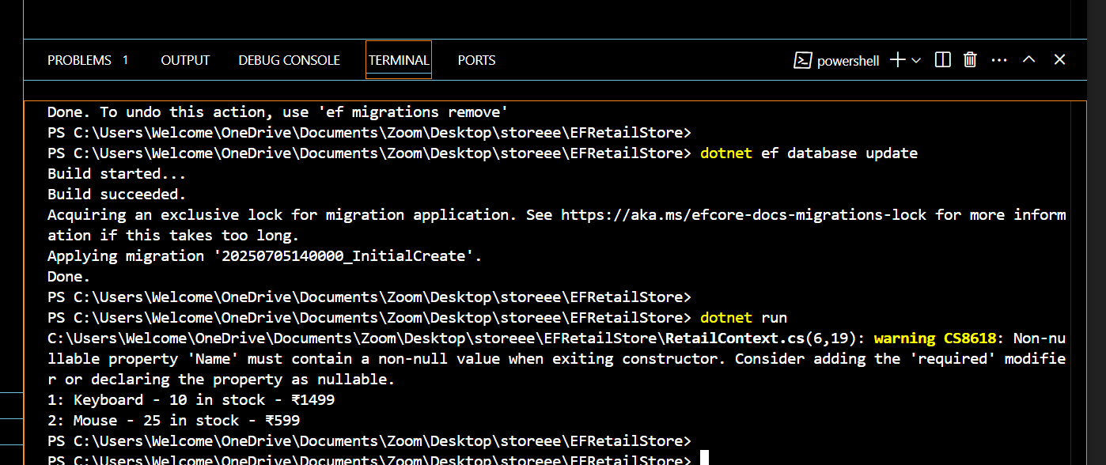

**Name:Ayushman Upadhyay**

**Email:2230164@kiit.ac.in**

**Superset Id: 6358125**